Myrtle Beach Citizens Police Academy
Alumni Association
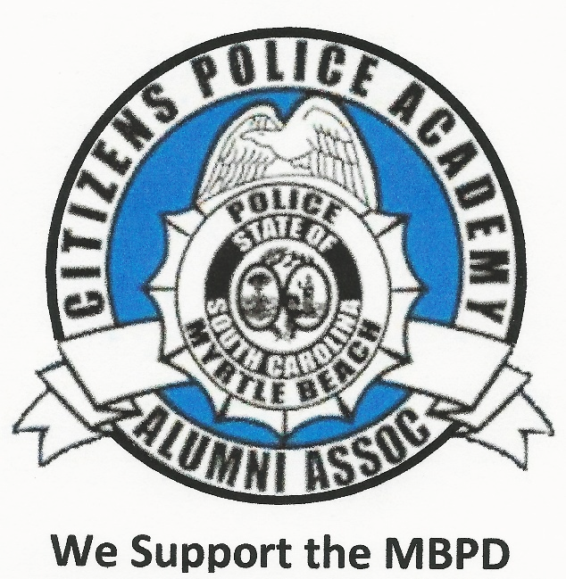

November 2023
To Whom it may Concern:
The Myrtle Beach Citizen’s Police Academy Alumni Association is seeking either monetary or food donations suitable for feeding the officers and support staff on both Thanksgiving Day and Christmas Day. There will be approximately 100 people on duty to feed within the various divisions and shifts. We’re calling on the entire community to help make this a reality. We need food/drink items or monetary donations/gift cards so that we might purchase needed items.
Your officers afford you protection even on holidays when most everyone else is celebrating with their families. This is an opportunity to show your appreciation and support!
Please visit our website photo gallery and scroll to past Holiday Meals to visualize the event and the officer’s appreciation. www.mbcpaaa.org
Thank you in advance for your generosity!
Sincerely,
Barbara Prescop
MBCPAAA President

